Main Handbook
Table of Contents
- Introduction
- Definitions
- Front Panel
- Outline of Code
- Misc. Items

I. Introduction
The Main program is the heart of the lab – it connects with the instruments and runs most of the scans. Almost every other program that has been written to date is connected in some form or fashion to the Main program. By itself, the Main program does not do much; its main responsibility is to coordinate the activities of all the other subVIs that write files, run scans or control instruments so that there is one, convenient place to control everything. This brief “handbook” describes the workings of the main program, both front panel-wise and code-wise, as well as some of the idiosyncrasies of the program.

II. Definitions
Scan mode
Experiment Mode
Status versus Setting
Count Time versus T-Time

III. Front Panel
The easiest way to get to Main is to use the Load Main icon on the desktop. This is a program that will load and launch the Main program for you. Alternatively, Main can be found in LabVIEW format at C:\LabVIEW\Main\Main vx.xx.vi or in application form under C:\LabVIEW\apps\Main\Main.exe. Once you load Main, you will notice that the first thing it does is look for attached instruments, via GPIB, RS-232 and USB connections. After this pop-up screen closes, Main will boot up and you should see a blinking light in the lower middle portion of the screen, indicating that Main is active and idle.
Once you have Main loaded, the front panel of Main is fairly easy to navigate. On the top, far right is the instrument array, which indicates the status of all the instruments. In the top, middle is the current instruments status box, which gives the status of all the instruments attached. This is updated about once a second. Progressing across the screen, on the left side you will see the scan settings box, which lists all the settings that are pertinent for the scan and experiment type you have selected.
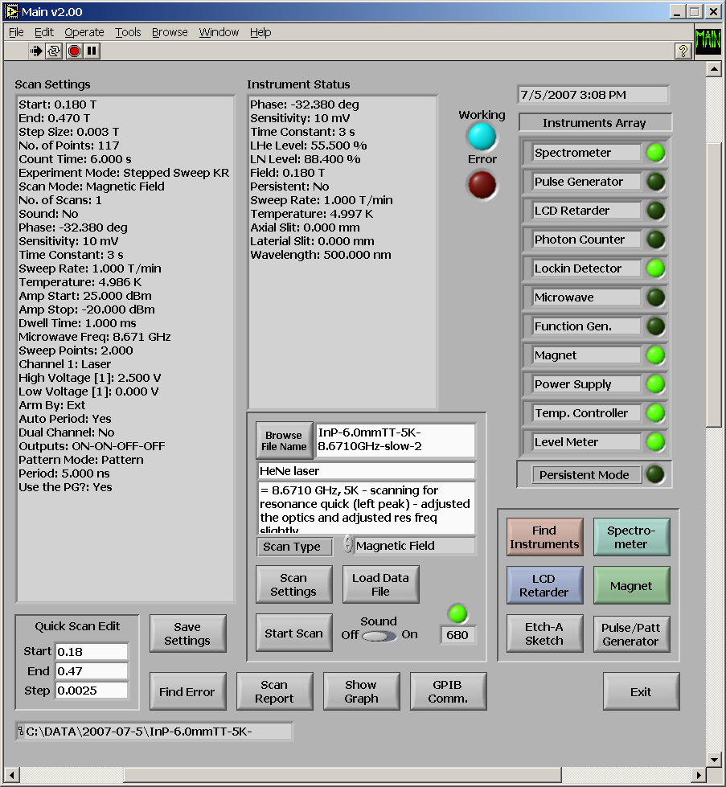
Figure 2.1: The front panel to Main.

IV. Outline of the Code

V. Misc. Items
Lists of string names for variables (from global variable)
-prefixes and general naming guides

Instrument parameters (GPIB #’s, abbrevs, etc)
Gen outline of how it runs

Temp files (while running scan)

Count Time vs T Time

Description of the different scans

Comments on error handling

Mention loading program

Problem with port com

Magnet: Primary versus secondary settings – talk about temp stable

Explain save settings button

Difference – settings (settings) versus status (currinstr)

Explain pulse gen setting menu (why disable?) → explain 2 channel and channel labels

Close slits when exit

What all the cols in the temp file mean

Abbrevs for scans/exp modes – describe use header – how store info (4 numbers – convert to binary arrays)

 |  | Wait Time | Pulse Width | Wavelength | B Field | rf Scan
1 | 1 | PEM | PEM | PEM | PEM | PEM
2 | 3 | LCD | LCD | LCD | LCD | ld
4 | 7 | 4chpc | 4chpc | 4chpc | 4chpc
8 | 15 | 4chpc | 4chpc | 4chpc | 4chpc
16 | 31 | Spin Echo PL |  | 1chpc | 1chpch
32 | 63 | Spin Echo LP |  |  | ld
64 | 127 | Spin Echo LD |  |  | ld (cont)
128 | 255
256 | 511

Explain mid to mid

Explain why PGarm, PGpatton? Are 1 and 0’s (b/c used as settings)

Explain trigger freq in wait time (to determine max ending point)

Note on why no longer load pattern while waiting for data

Portcom and magnet – when using .exe, labview must be closed! Try to access same thing at same time

Note about sweep repeat action for microwave generator

